**Date of interview:**

**Information about the parent:**

**Your gender:** Female Male **Your age:_______________________________**



**Are you Hispanic or Latina?** Yes No



**Current Marital Status:** Single Divorced Widowed Living with partner Married Other



**Annual household income:** Under 15,000 15,000-25,000 35,000-50,000 above 50,000



**Parental Education:** Less than high school degree Some college High school degree College degree



Advanced college degree



**Work Hours:** Full time Part-time Unemployed Stay home parent



**Do you have any medical condition that alters your eating habits?** Yes No **If yes, please list them__________________________**



**Primary language spoken at home: __________________ Other languages: ____________________**

**Please pick the figure that best represents you at this moment.**

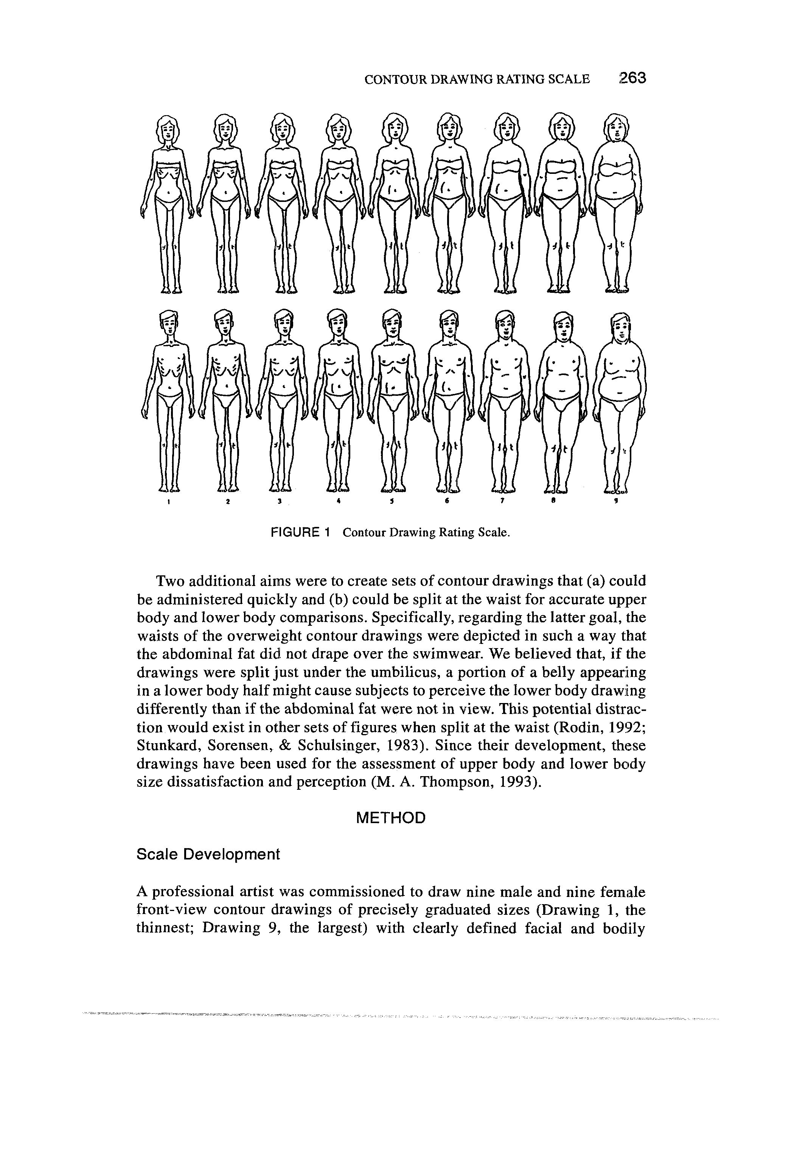

1 2 3 4 5 6 7 8 9 1 2 3 4 5 6 7 8 9

**Information about the child:**

**Gender of child:** Female Male **Age of child:**______________________ **Your relationship to the child:_____________**



**Is your child Hispanic/latino?** Yes No **If not, list the race/ethnicity of the child______________________________________**



**Does your child have any medical condition that alters his/her eating habits?** Yes No **If yes, please list them__________________________**



**Please pick the figure that best represents your child at this moment.**

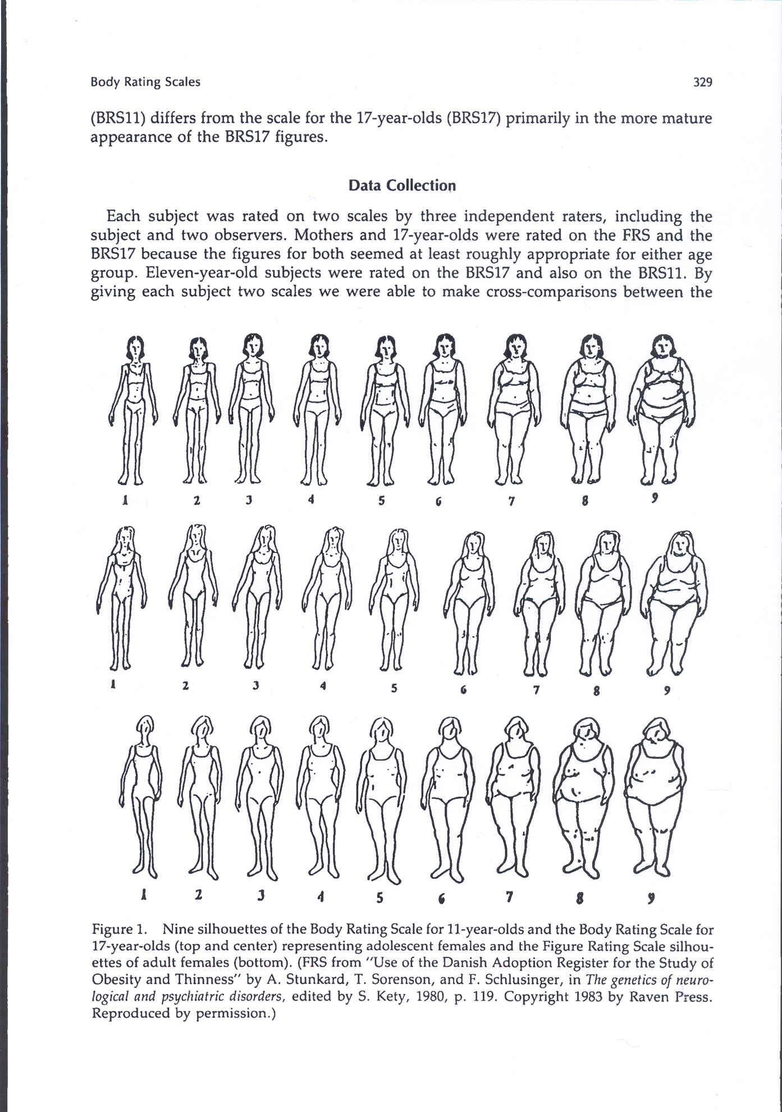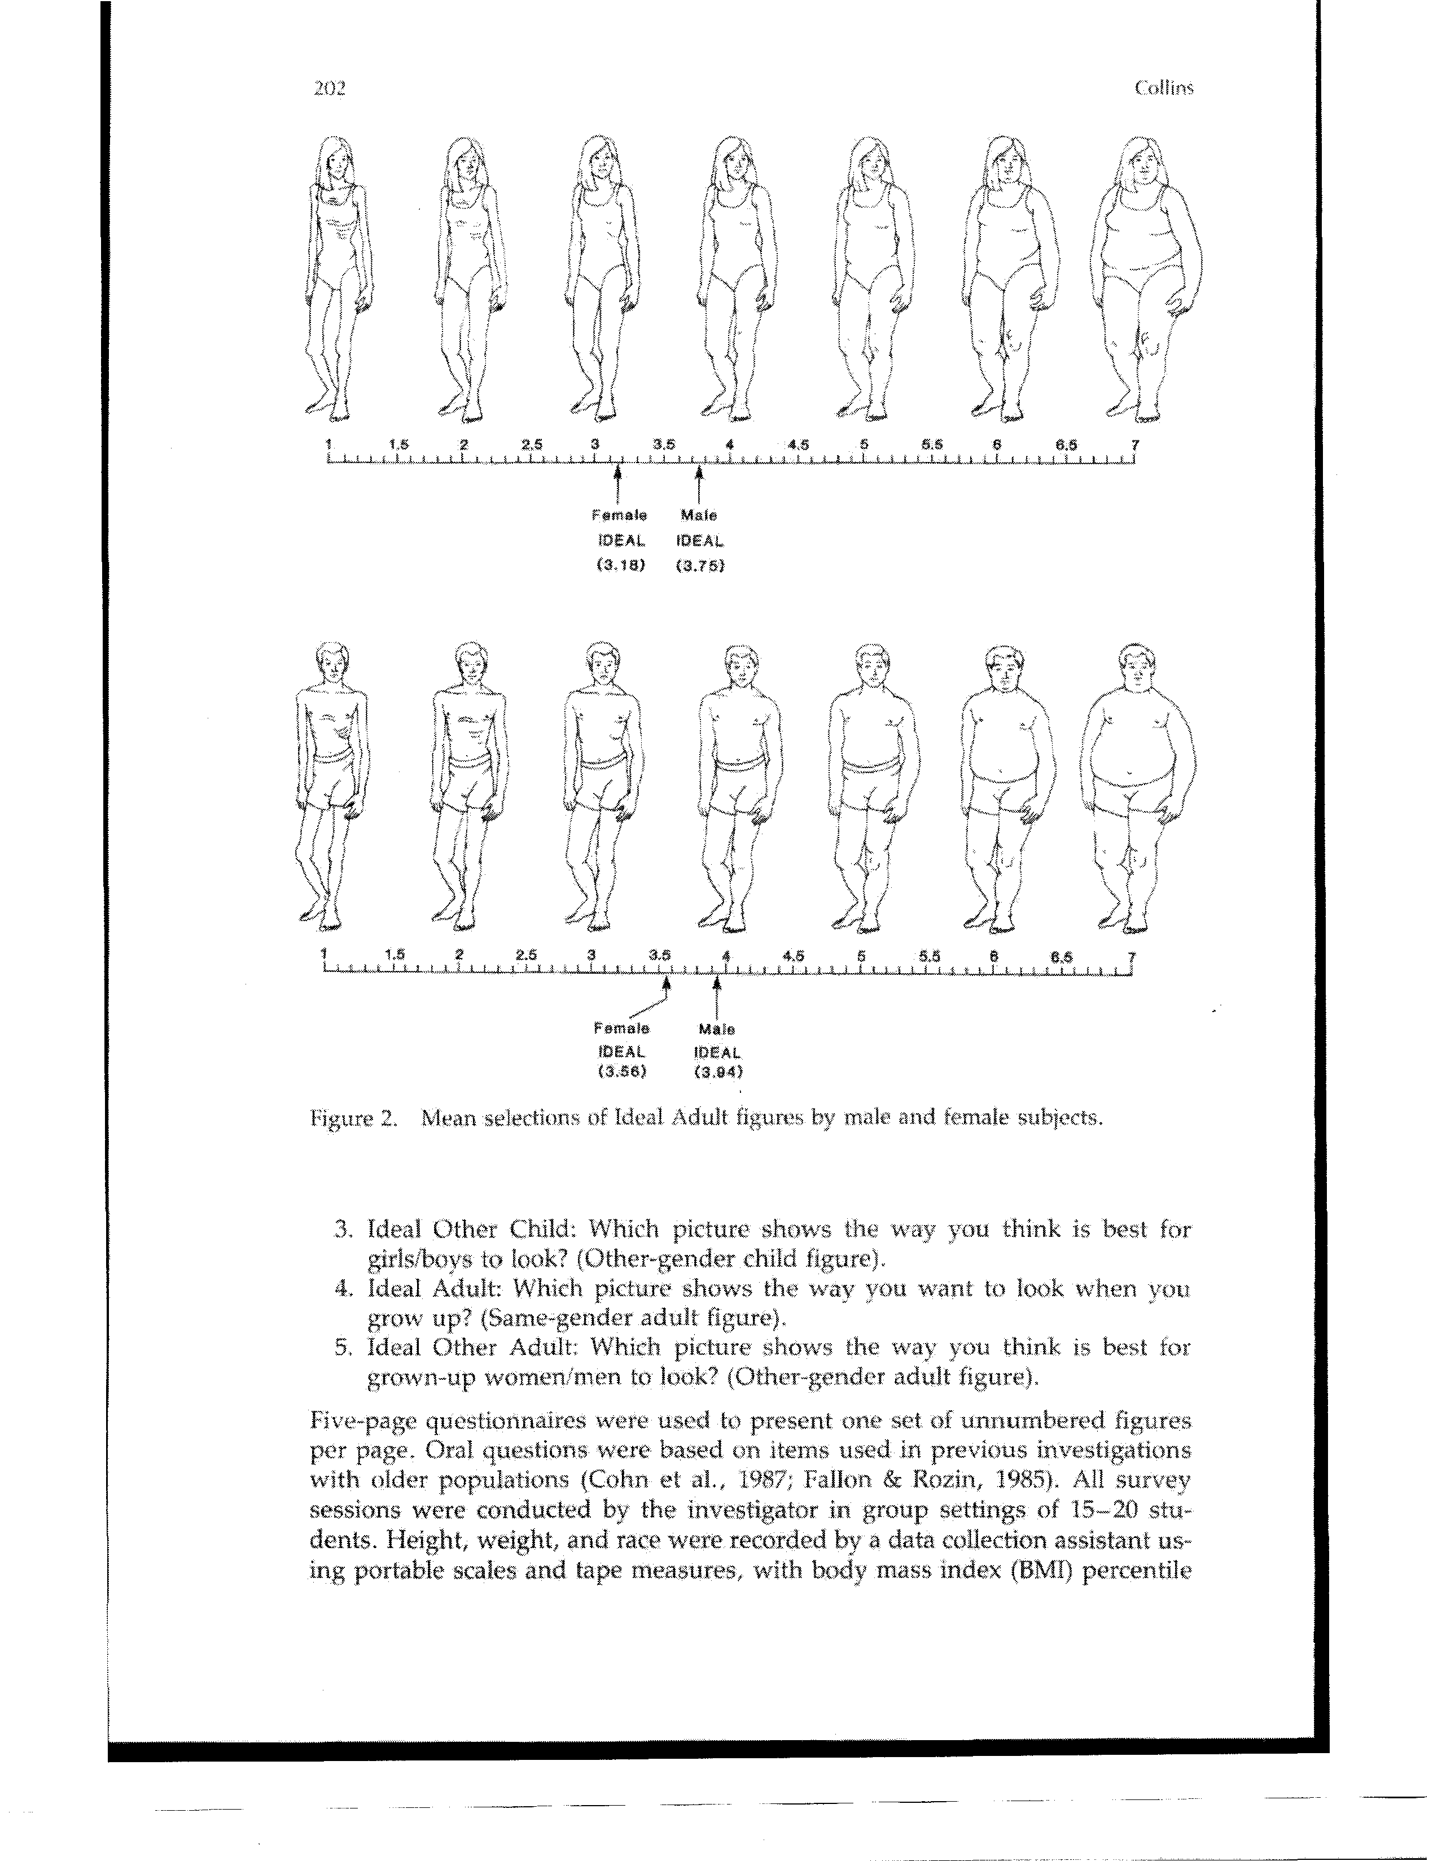

**1 2 3 4 5 6 7 8 9 1 2 3 4 5 6 7**

**Please answer the following questions to the best of your ability.**

1. How many days in the past week have you give **fruits & vegetables** to your children?

3. How many days in the past week have you give **donuts, candy, hamburgers, nuggets, chips, pizza** to your children? 1 2 3 4 5 6 7

5. Do you feel that you have enough time to cook? Yes No



6. I really like to cook. 1 2 3 4 5

Strongly Disagree Neutral Agree Strongly   
 Disagree Agree

9. Who does it typically give the children food? ________________________________________________

|  |  |  |  |  |  |
| --- | --- | --- | --- | --- | --- |
| **Please mark the degree to which you agree with the following statements with 5 being Strongly Agree and 1 being Strongly Disagree. Please choose only answer per question.** | **Strongly Disagree** | **Disagree** | **Neutral** | **Agree** | **Strongly  Agree** |
| 1. I want to give **fruits & vegetables** to my children during the week. | 1 | 2 | 3 | 4 | 5 |
| 2. I want to give **candy, donuts, hamburgers, nuggets, chips, pizza** to my children during the week. | 1 | 2 | 3 | 4 | 5 |
| 3. I intend to give **fruits & vegetables** to my children during the week. | 1 | 2 | 3 | 4 | 5 |
| 4. I intend to give **candy, donuts, hamburgers, nuggets, chips, pizza** to my children during the week. | 1 | 2 | 3 | 4 | 5 |
| 5. I am sure I will give **fruits and vegetables** to my children during the week | 1 | 2 | 3 | 4 | 5 |
| 6. I am sure I will give **candy, donuts, hamburgers, nuggets, chips, pizza** to my children during the week | 1 | 2 | 3 | 4 | 5 |
| 7. Giving **fruits & vegetables** to my children during the week is beneficial thing to do. | 1 | 2 | 3 | 4 | 5 |
| 8 Giving **candy, donuts,** **hamburgers, nuggets, chips, pizza** to my children during the week is beneficial thing to do. | 1 | 2 | 3 | 4 | 5 |
| 9. Giving **fruits** **& vegetables** to my children during the week is valuable. | 1 | 2 | 3 | 4 | 5 |
| 10. Giving **candy, donuts, hamburgers, nuggets, chips, pizza** to my children during the week is valuable. | 1 | 2 | 3 | 4 | 5 |
| 11. I think it is tasty to give **fruits and vegetables** to my children during the week. | 1 | 2 | 3 | 4 | 5 |
| 12. I think it is tasty to give **candy, donuts, hamburgers, nuggets, chips, pizza** to my children during the week. | 1 | 2 | 3 | 4 | 5 |
| 13. I think that giving **fruits and vegetables** to my children is necessary during the week. | 1 | 2 | 3 | 4 | 5 |
| 14. I think that giving **candy, donuts, hamburgers, nuggets, chips, pizza** to my children is necessary during the week. | 1 | 2 | 3 | 4 | 5 |
| 15. Most people who are important to me think that I should give **fruits & vegetables** to my children during the week. | 1 | 2 | 3 | 4 | 5 |
| 16. Most people who are important to me think that I should give **candy, donuts, hamburgers, nuggets, chips, pizza** to my children during the week. | 1 | 2 | 3 | 4 | 5 |
| **Please mark the degree to which you agree with the following statements with 5 being Strongly Agree and 1 being Strongly Disagree. Please choose only answer per question.** | **Strongly Disagree** | **Disagree** | **Neutral** | **Agree** | **Strongly  Agree** |
| 17. It is expected of me that I give **fruits** **& vegetables** to my children during the week. | 1 | 2 | 3 | 4 | 5 |
| 18. It is expected of me that I give **candy, donuts hamburgers, nuggets, chips, pizza** to my children during the week. | 1 | 2 | 3 | 4 | 5 |
| 19. I feel under social pressure to give **fruits** **& vegetables** to my children during the week. | 1 | 2 | 3 | 4 | 5 |
| 20. I feel under social pressure to give **candy, donuts, hamburgers, nuggets, chips, pizza** to my children during the week. | 1 | 2 | 3 | 4 | 5 |
| 21. My friends think it is right that I give **fruits and vegetables** to my children during the week | 1 | 2 | 3 | 4 | 5 |
| 22. My friends think it is right that I give **candy, donuts, hamburgers, nuggets, chips, pizza** to my children during the week | 1 | 2 | 3 | 4 | 5 |
| 23. My parents or relatives tell me that it is important to give **fruits and vegetables** to children during the week. | 1 | 2 | 3 | 4 | 5 |
| 24. My parents or relatives tell me that it is important to give **candy, donuts, hamburgers, nuggets, chips, pizza** to children during the week. | 1 | 2 | 3 | 4 | 5 |
| 25. For me to give **fruits & vegetables** to my children during the week would be possible. | 1 | 2 | 3 | 4 | 5 |
| 26. For me to give **donuts, candy, hamburgers, nuggets, chips, pizza** to my children during the week would be possible. | 1 | 2 | 3 | 4 | 5 |
| 27. I am confident that I could give **fruits & vegetables** to my children in the following week. | 1 | 2 | 3 | 4 | 5 |
| 28. I am confident that I could give **candy, donuts, hamburgers, nuggets, chips, pizza** to my children in the following week. | 1 | 2 | 3 | 4 | 5 |
| 29. The decision to give **fruits & vegetables** to my children during the week is beyond my control. |  |  |  |  |  |
| 30. The decision to give **candy, donuts, hamburgers, nuggets, chips, pizza** to my children during the week is beyond my control. | 1 | 2 | 3 | 4 | 5 |
| 31. Whether or not I give **fruits & vegetables** to my children during the week is completely up to me. | 1 | 2 | 3 | 4 | 5 |
| 32. Whether or not I give to my children **candy, donuts, hamburgers, nuggets, chips, pizza** to my children during the week is completely up to me. | 1 | 2 | 3 | 4 | 5 |